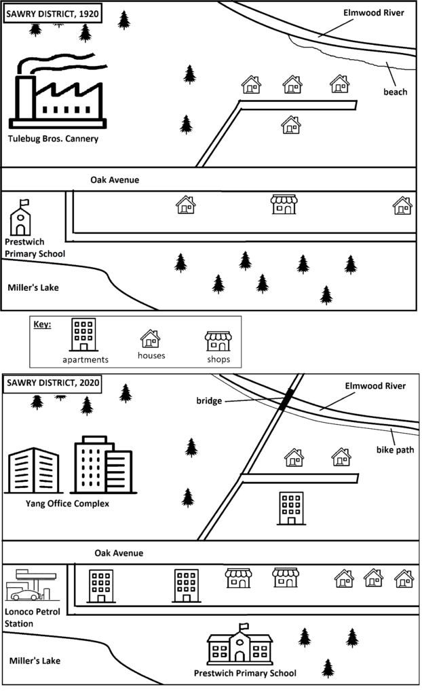

**Model Essay**

This pair of maps depicts change over the course of a century in the Sawry District neighborhood by showing the area in 1920 and 2020.

The overall change in the neighborhood is one of growth. By 2020 there are more businesses, more housing, and greater public services. However, not all businesses and services remained intact after 1920.

Business and housing saw the most change and growth. The cannery present in 1920 was replaced by an office complex. Two of the houses near the Elmwood River were demolished and replaced by a road and an apartment complex. Oak Avenue went from having two houses and a shop to having three houses, two shops, an apartment complex, and a petrol station.

The change in public services was less significant than the change in housing and businesses. Prestwich Primary School was demolished and then rebuilt as a bigger school, closer to Oak Street’s shops. And Elmwood River gained a bridge and a bike path, the latter of which replaced the small beach seen on the 1920 map.